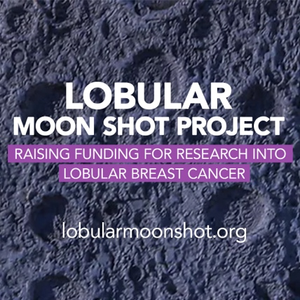

**ADAPT AREAS IN RED**

INSERT YOUR ADDRESS HERE

INSERT THE ADDRESS OF YOUR MP

Ref: Lobular Breast Cancer

INSERT DATE HERE

Dear INSERT NAME

I am writing to you about lobular breast cancer. I have (or my sister….. has) Invasive Lobular Breast Cancer. I/my sister/wife/daughter/mother….was (brief summary – max 3 lines, such as My lobular breast cancer was missed on mammongram screening xx times and I was finally diagnosed with xx lobular breast cancer in 2013, which has now progressed to secondary lobular breast cancer with the cancer in my bones).

One in seven women will be diagnosed with breast cancer in their lifetime. The second most common type of breast cancer is **Invasive Lobular Breast Cancer (ILC)**. 1,000 people a day (22 a day in the UK), are being diagnosed with ILC, a breast cancer that generally fails to be seen on mammograms.

Currently, ILC has no specific treatment but with research funding, the **Manchester Breast Centre (MBC)**, which is part of the University of Manchester, could help change this. By bringing together national and international researchers, the exact biology of ILC could be understood. This would enable scientists, to then develop a specific treatment for those diagnosed, provide much better outcomes and save the NHS millions in the long-term.

The **Lobular Moon Shot Project** was set up in 2023 to raise this urgently needed research funding. It is run by a number of volunteer women diagnosed with ILC and their families. 135 MPs of all political parties currently support the project and the number grows every week. A full list of supporting MPs is available at: lobularmoonshot.org/supporters

I am writing to ask you to support the project and to urge the Government to support the Lobular Moon Shot Project and get MBC the funding they urgently need.

ILC is often called the ‘forgotten’ or ‘hidden’ cancer. It has been known since the mid 1970s that ILC behaves very differently to the most common type of breast cancer (Invasive Ductal Breast Cancer - IDC). However, to date, it is not diagnosed or treated differently to IDC.

Our Lobular Moon Shot Project is supported by educational films on our website which we encourage you to watch.

Key problem areas relevant to ILC are as follows:

* ILC generally fails to show up on mammograms/ultrasounds, the main diagnosis tool for breast cancer early detection screening (because ILC cells run in single lines - like a spider’s web, rather than forming a lump);
* ILC is usually diagnosed much later and at a more advanced stage;
* ILC does not have its own specific treatment, despite showing differing clinicopathological and biological features (Oesterreich, 2022, Van Baelen, 2022);
* Poorer long-term outcomes for ILC patients;
* Reoccurrences can occur 10 years+ after initial diagnosis, whereas the standard breast cancer approach finishes at 5 years;
* Research funding has effectively all gone to the main type of breast cancer – IDC;
* ILC is the 6th main type of female cancer in terms of numbers. It is more common than skin/melanoma, ovarian and brain cancers;
* 1,000 people a day are globally diagnosed with ILC, which will equate to almost 4 million newly diagnosed cases in the next 10 years (WHO). In Europe, for example, in 2022, 576,300 women were diagnosed with breast cancer, of which 86,500 will have been lobular breast cancer;

The lack of a specific treatment for ILC is a global problem. There are pockets of research going on internationally with a lobular focus, but it is far from enough. The larger breast and cancer charities have not given ILC the focus and funding that it requires. Breast Cancer Now, have to date, allocated under 1% of their research funding to lobular breast cancer.

Under the banner of the ‘Lobular Moon Shot Project’, we asked the MBC to draw up a research proposal for a dedicated ILC research project. They have outlined that ultimately, £20 million would be needed to undertake this collaborative research project. This equates to under £240 per person in the UK who will be diagnosed with ILC in the next 10 years. This would improve outcomes for those diagnosed with ILC, save the NHS millions and enhance national productivity.

Please ask the government to significantly support the MBC ‘Lobular Moon Shot Project’. This will benefit your constituents and citizens of every country, people all facing the same current problem. Being diagnosed with a disease with no specific treatment – this research project can change this.

On behalf of all those diagnosed with lobular breast cancer, we look forward to receiving your proactive response. This would help ensure a specific treatment becomes available as soon as possible to end what is effectively a one size fits all approach to breast cancer.

Yours sincerely,

INSERT YOUR NAME

INSERT YOUR DIAGNOSIS DATE e.g. Diagnosed with ILC in 2013 – Metastatic ILC in 2021

[INSERT](mailto:office@lobularmoonshot.org) YOUR EMAIL ADDRRESS

